Board Member Candidates

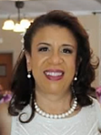
Annabel Santana-Colón has more than 32 years of administrative and leadership experience in higher education and public health. She currently serves as Associate Dean for Special Projects and Chief of Staff to the Dean of the CUNY School of Medicine in New York City, where she has served for 27 years. Previous roles include Clinical Campus Coordinator and Director of Educational and Faculty Affairs. A member of La Hermosa Christian Church in New York City, she serves as Board moderator and as an adult Christian Education teacher. Upon retirement in May 2026, she will be transitioning to the state of Florida and looks forward to attending the First Christian Church of Deland. Annabel holds a Master of Public Health degree in health administration from Columbia University School of Public Health. A creative writer, she published her first book, The Day the Telegram Came (Christian Faith Publishing) in 2021.

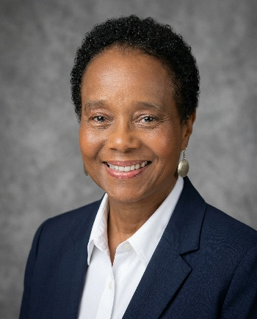
Jacqueline L. (Jackie) Nesbit is the founder and principal of Audit & Risk Management Solutions, an internal audit and risk management consulting firm serving community banks and other organizations since 2005. She previously spent more than two decades in internal audit at the National Bank of Commerce in Memphis (now Truist), including twelve years as Chief Audit Executive. Jackie holds bachelor's and master’s degrees in business administration from Christian Brothers University, is a graduate of the Graduate School of Banking at Louisiana State University, and is a Certified Public Accountant. Jackie is an active member of Mississippi Boulevard Christian Church where she serves in the Greeters Ministry and previously served on the Stewardship and Administration and Finance Committees, as well as chair of the Audit Committee. Her past community involvement has included various roles on the boards of the Community Foundation of Greater Memphis, Christian Brothers University, Habitat for Humanity of Greater Memphis, Bridges USA, and several municipal boards. An avid sports fan, she has been a Memphis Grizzlies season ticket holder for 25 years and enjoys cycling, walking, and following NBA and Memphis Tigers basketball, along with professional tennis.

